Naive Bayes Classifier

Independent Events in Probability

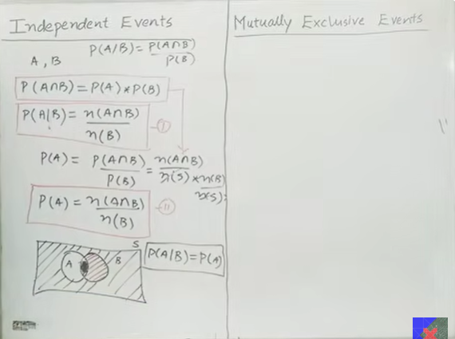

Definition
Two events are called Independent Events if the occurrence of one event does not affect the probability of the other event.
In other words,
Knowing that event B has occurred does not change the probability of A.

Conditional Probability Formula
P(A|B) = P(A ∩ B) / P(B)
where
P(B) ≠ 0

Property of Independent Events
For independent events,
P(A|B) = P(A)
This means
Probability of A remains the same even after B has occurred.

Derivation
From conditional probability,
P(A|B) = P(A ∩ B) / P(B)
Since A and B are independent,
P(A|B) = P(A)
Therefore,
P(A) = P(A ∩ B) / P(B)
Multiplying both sides by P(B),
P(A ∩ B) = P(A) × P(B)
This is the most important formula for independent events.

Formula Using Number of Outcomes
From conditional probability,
P(A|B) = n(A ∩ B) / n(B)
For independent events,
P(A|B) = P(A)
Therefore,
P(A) = n(A ∩ B) / n(B)
where
- n(A ∩ B) = Number of common outcomes
- n(B) = Number of outcomes in event B

Venn Diagram
S (Sample Space)

+--------------------------+
| |
| ________ |
| / A \ |
| / ∩ \ |
| \ B / |
| \_______ / |
| |
+--------------------------+
For independent events,
P(A|B) = P(A)

Example
Suppose
P(A) = 0.4
P(B) = 0.5
Since A and B are independent,
P(A ∩ B)

= P(A) × P(B)

= 0.4 × 0.5

= 0.20

